Global Event Management Systems

G.E.M.S

USER MANUAL

Contents

1.0 Document Foreword 2

2.0 Initial Webpage 3

3.0 Admin Portal 4

4.0 Current Events 5

5.0 Check-in page 7

6.0 Payment Terminal 8

7.0 Booking Successful 9

# Document Foreword

This document is designed as a guide for the user to be able to navigate the Global Event Management Systems, or known as G.E.M.S for short. This document will provide screenshots of the relevant webpages and how the guest will navigate it.

# 2.0 Initial Webpage

To interact with the website the user of the website, referred to as the guest from henceforth, will need to navigate to the following website URL in a browser of their choice:

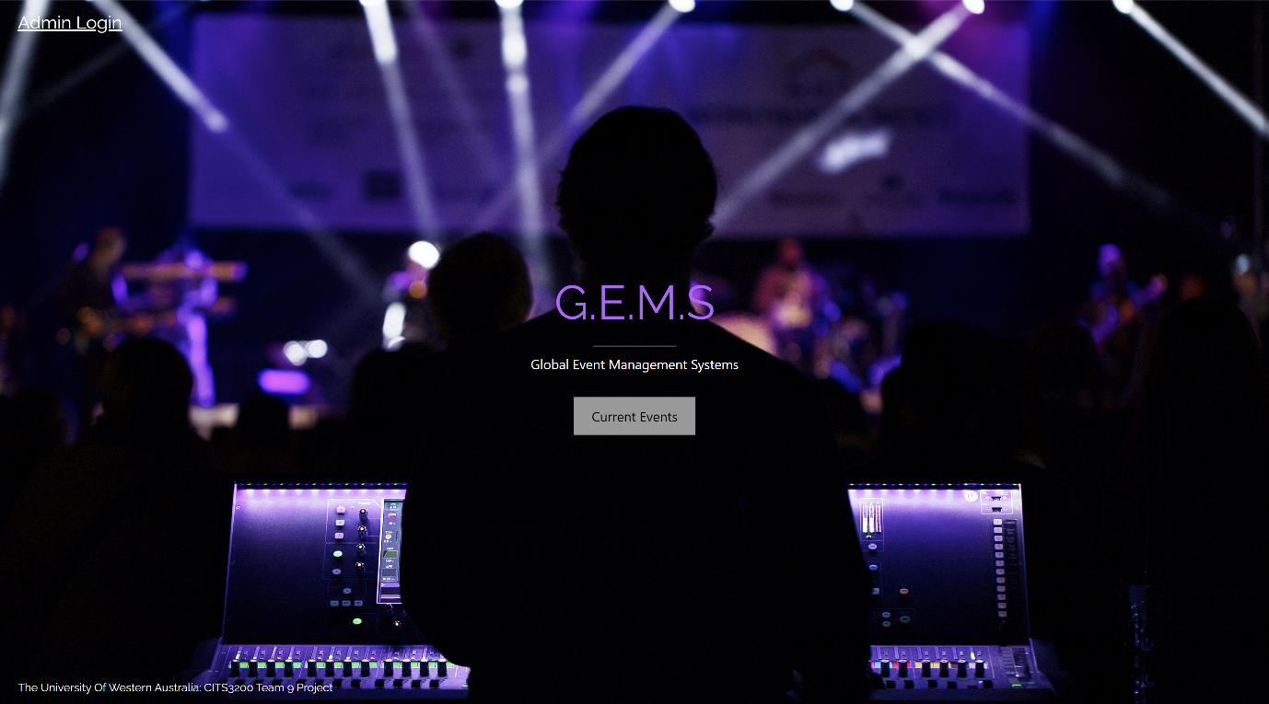Once at the URL, the user will be presented the home page (or landing page) as seen below in figures 1 and 2. From here the user can either navigate to the hyperlink “Admin Login” or the button “Current Events.” If the user clicks on the “Admin Login” link, they will be redirected to the admin login page which for further information can be seen in section 3.0. It is intended that the user will click on the Current Events button and as such has been positioned in the centre of the webpage for this exact effect. Once the user clicks on the “Current Events” they will be redirected to a webpage that lists the current events, for further information see section 4.0.

Figure 1: G.E.M.S Landing/Home page

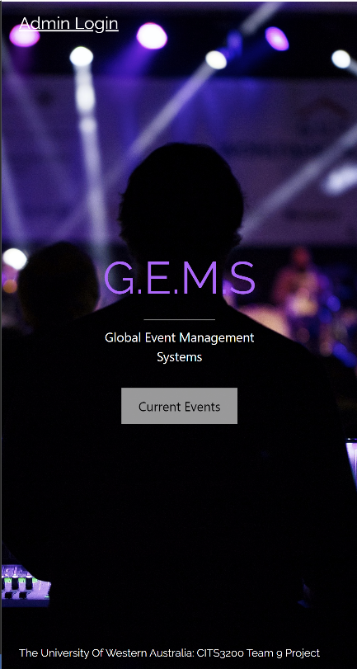Figure 2: Mobile view of G.E.M.S landing/home page

# 3.0 Admin Portal

This section is not designed to be used by the guests to the websites. As such it is protected by a login system which can only accessed when the correct usernames and passwords are entered as seen in figures 3 and 4. If a user accidentally clicks on the admin portal page, then can click “G.E.M.S” on the top navigational bar to navigate back to the landing page, see section 2.0. They can also click on “Current Events” to navigate to a list of events, see section 4.0.

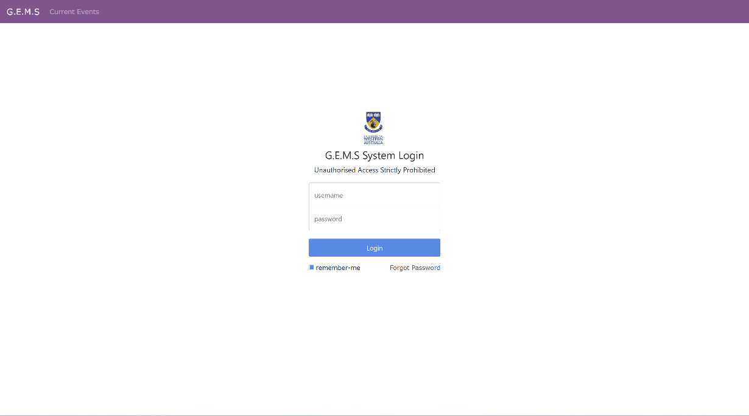

Figure 3: Admin login page

Figure 4: Mobile view of admin page

# 4.0 Current Events

This section lists all the current events that are available for the guest to check-in to which can be seen below in figure 5. If the user clicks on “G.E.M.S” in the top navigation bar they are redirected to the home page, which can be seen in section 2. Clicking on the “Current Events” button will refresh the page for the guest, and this can be particularly helpful for the guest to check if new events are available. The guest can click anywhere in the white outline of the event to be directed to a page which asks the guest to enter their information so that they can log in to the webpage, seen in section 5.

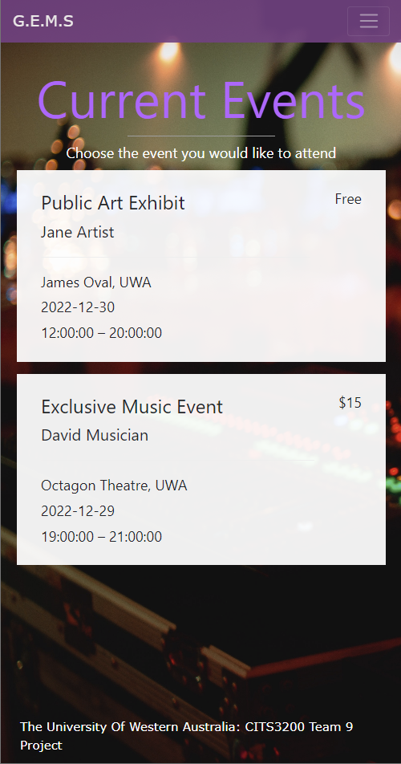Figure 5: Current Events page

Figure 6: Mobile view of Current Events page

# 5.0 Check-in page

This section allows the guest to check-in to a specific event. On the top navigation bar, if the guest clicks “G.E.M.S” they are navigated back to the homepage, see section 2, and if they click “Current Events” they are navigated to a page which lists the current events, see section 4. In the check-in page the guest can enter their firstname, lastname, email, mobile no, dietary requirements and specify if there are any additional guests to the event. They can also upload an image that will be used for their badging. Once they have entered in their details, they will either be directed to section 6, if it is a paid event or section 7.

Figure 7: Event Check-in page

Figure 8: Mobile view of Event Check-in page

# 6.0 Payment Terminal

The guest will be redirected to this section if the event requires payment. The secure payment portal as seen below in figure 9, has been implemented with Stripe. As such the guest can choose to pay with Apple Pay, Google Pay or enter in their credit-card details. Once the guest has entered in their payment details, they can click the “Pay” button which, if the payment was successful, will redirect them to section 7.

Figure 9: Stripe Payment Portal

Figure 10: Mobile view of Stripe Payment Portal

# 7.0 Booking Successful

Once a booking is successful, the guest will be redirected to this page which can be seen below in figure 11 and they will be sent an email which indicates that they have been successful in checking in along with their badge for the event. The guest can now, without worry navigate to another page.

Figure 11: Booking successful page

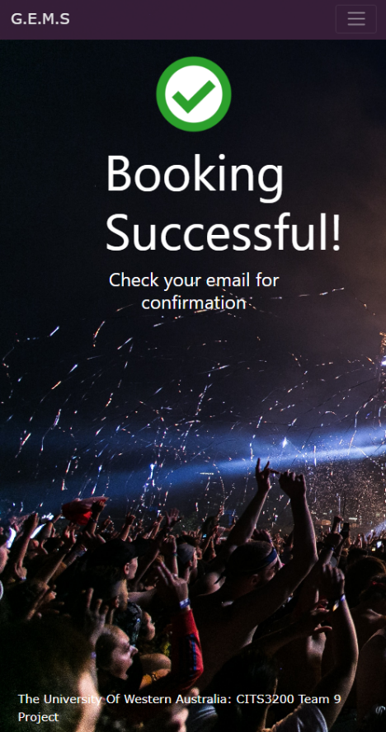Figure 12: Mobile view of Booking successful page